

**AI-POWERED SMART**

**MONITORING FOR**

**AGRICULTURAL AND FOREST BORDERS**



**RASA.AI LABS**

**Hackathon 2025**

**YOSHVA J**

Prepared by:

Presented to:

# **Project Overview**

This project introduces an AI-powered surveillance and deterrent system designed to safe- guard agricultural lands and forest-adjacent areas from wildlife intrusions, bird-related damage, and unauthorized human entry. By leveraging advanced computer vision, real- time alerting, and cloud-based storage, the system offers a scalable, automated solution for rural farmers and forest authorities. The solution addresses critical challenges such as crop loss, safety threats, and labor-intensive manual monitoring, providing a modern alternative to outdated deterrent methods like shouting or firecrackers.

## **Team Information**

Team Member: Yoshva

Preethipa C (Mentor)

Contact Information:

• Email: [yoshva2003@gmail.com](mailto:yoshva2003@gmail.com)

* Phone: +91 7904561291

Contributions: • Developed and integrated the FastAPI backend using Python.

* Trained and deployed YOLOv8 for object and animal detection.
* Set up InsightFace for accurate face authentication.
* Developed a chatbot interface using LangChain and OpenAI.
* Integrated Google Drive and Twilio APIs for cloud storage and real-time alerts.
* Conducted farmer surveys to align system features with user needs.
* Built a PostgreSQL logging system for traceable detections and authentications.

## **Problem Statement**

Rural areas along forest borders face significant challenges due to animal and intruder activities, leading to:

* Crop Loss: 76% of farmers report crop damage caused by animals.
* Bird Infestations: 60% of farmers experience seasonal bird-related crop destruction.
* Safety and Equipment Risks: Unauthorized human entry and wildlife intrusions pose safety threats and cause equipment damage.
* Lack of Monitoring: 85% of farmers lack real-time monitoring or deterrent systems.

Traditional methods like shouting, firecrackers, or physical fences are labor-intensive, inconsistent, and often ineffective, resulting in:

* Revenue losses for farmers.
* Disruptions in food supply chains.
* Increased human-wildlife conflict.
* Time-consuming manual monitoring efforts.

## **Solution Summary**

The proposed system is an intelligent, automated surveillance and deterrent solution that addresses these challenges through:

* Real-time detection of animals (e.g., sheep, birds) and humans using YOLOv8.
* Face authentication via InsightFace to distinguish authorized staff from intruders.
* Automated sound deterrents (e.g., tiger growls for animals, firecracker sounds for birds).
* Real-time SMS and voice alerts sent to farmers or oﬀicials via Twilio API.
* Cloud storage of detection snapshots and videos using Google Drive API.
* A chatbot interface powered by LangChain and OpenAI for natural language queries about detection logs.

This system is designed for deployment in border farms, forest department monitoring stations, and wildlife-prone agricultural lands, offering a practical and scalable solution.

# **Technical Implementation**

## **Architecture Overview**

The system architecture integrates multiple components for seamless operation:

* Input Layer: Webcam captures real-time video feed.
* Processing Layer: YOLOv8 processes frames for object detection (animals, hu- mans).
* Authentication Layer: InsightFace verifies faces to filter authorized personnel.
* Action Layer: Triggers specific deterrent sounds based on detection type.
* Storage and Logging: Snapshots are saved, logged in PostgreSQL, and uploaded to Google Drive.
* Alerting: Twilio API sends SMS and voice alerts to users.
* User Interaction: A chatbot interface allows natural language queries on detection logs.

## **Technology Stack**

The technology stack is chosen for performance, scalability, and reliability:

Layer Technology Used

Frontend Angular (separate UI application) Backend FastAPI (Python)

ML Models YOLOv8 (object detection), InsightFace (face authentication) Storage PostgreSQL (detections, logs, uploads)

Cloud Google Drive API (snapshots and videos) Alerts Twilio (SMS and voice calls)

Chatbot LangChain + OpenAI + PostgreSQL

Table 1: Technology Stack Overview

* + 1. **Justification for Technology Choices**
       - YOLOv8n: Lightweight and optimized for edge devices, ensuring fast object detection in resource-constrained environments.
       - InsightFace: Provides state-of-the-art accuracy for real-world face recognition.
       - FastAPI: Offers high performance and asynchronous processing for real-time applications.
       - PostgreSQL: Reliable for structured logging and querying of detection data.
       - Twilio and Google Drive APIs: Well-documented, scalable, and reliable for alerting and cloud storage.
       - LangChain + OpenAI: Simplifies natural language processing for user-friendly log queries.

## **Key Features**

1. Face Authentication: Prevents false alerts by identifying authorized staff using InsightFace.
2. Animal and Bird Detection: Real-time detection of animals (e.g., sheep) and birds using YOLOv8.
3. Sound Deterrent System: Plays context-specific sounds (e.g., tiger.mp3 for animals, crackers.mp3 for birds) to deter intrusions.
4. Alert System: Sends immediate SMS and voice alerts to farmers or oﬀicials via Twilio API.
5. Cloud Integration: Automatically uploads timestamped snapshots and videos to Google Drive for secure storage.
6. PostgreSQL Logging: Maintains detailed logs of detections, authentications, and uploads for traceability.
7. Chatbot Interface: Allows users to query detection logs in natural language (e.g., “Show me all unknown person entries today”).

# **System Workflow**

The system operates in a streamlined workflow:

1. Video Capture: A webcam continuously captures video frames from the monitored area.
2. Object Detection: YOLOv8 processes frames to detect animals, birds, or humans.
3. Face Verification: If a human is detected, InsightFace checks if the individual is authorized.
4. Deterrent Action: If an unauthorized human or animal is detected, the system triggers a pre-configured sound (e.g., tiger growl for animals).
5. Logging and Storage: The system logs the detection event in PostgreSQL and uploads a snapshot or video to Google Drive.
6. User Notification: Twilio API sends an SMS or voice alert to the farmer or oﬀicial.
7. Query Interface: Users can interact with the chatbot to retrieve detection logs or

system status using natural language.

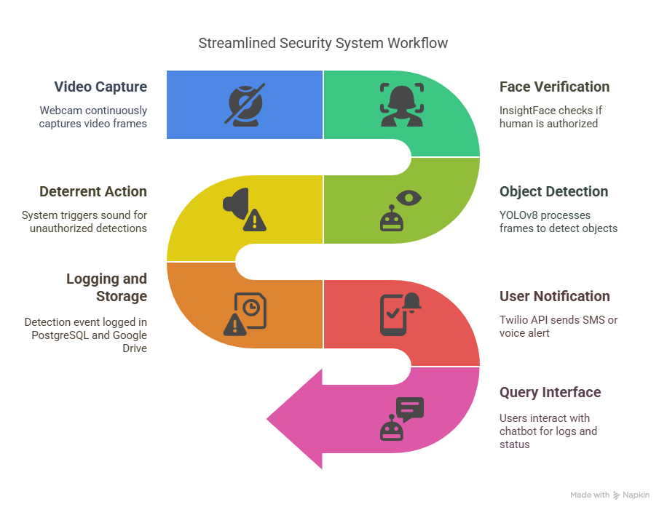

# **Implementation Details**

## **Development Process**

* Farmer Surveys: Conducted interviews with farmers to identify key pain points, such as crop loss and lack of real-time monitoring.
* Model Training: YOLOv8 was trained on a custom dataset of animals (sheep, birds) and humans, optimized for edge deployment.
* Backend Development: FastAPI was used to create RESTful endpoints for video processing, logging, and API integrations.
* Frontend Design: Angular-based UI provides a dashboard for system status and log visualization.
* API Integrations: Google Drive and Twilio APIs were integrated for cloud storage and real-time alerts.
* Chatbot Development: LangChain and OpenAI were used to build a natural language interface for querying PostgreSQL logs.

## **Challenges and Solutions**

* Challenge: Limited computational resources in rural settings.
* Solution: Used YOLOv8n, a lightweight model optimized for edge devices.
* Challenge: False positives from staff triggering alerts.
* Solution: Integrated InsightFace for accurate face authentication to filter authorized personnel.
* Challenge: Connectivity issues in remote areas.
* Solution: Designed the system to cache logs locally and sync with Google Drive when connectivity is available.

# **Future Enhancements and Conclusion**

## **Future Enhancements**

* Expanded Detection Classes: Add support for more animal species and environ- mental threats (e.g., fire detection).
* Mobile App Integration: Develop a dedicated mobile app for real-time alerts and system control.
* Solar-Powered Hardware: Integrate solar-powered cameras and edge devices for off-grid deployment.
* Advanced Analytics: Implement predictive analytics to forecast intrusion patterns based on historical data.

## **Conclusion**

The AI-Powered Smart Monitoring System provides a robust, scalable solution for protecting agricultural and forest-adjacent areas from wildlife and unauthorized intrusions. By combining real-time object detection, face authentication, automated deterrents, and cloud-based storage, the system reduces crop losses, enhances safety, and minimizes human-wildlife conflict. The integration of a chatbot interface ensures user-friendly access to detection logs, making the system accessible to non-technical users. With its lightweight design and reliable technology stack, this solution is well-suited for deployment in rural and remote areas, offering significant value to farmers and forest authorities.